**Writing for the Web**



**WRITE TO LEARN**

Think about all of the ways you use the Internet. Then try to imagine your life without the Internet. What would it be like? Write a short journal entry describing how your life would be different if there were no Internet.



*Focus on Writing for the Web*

Read the sample document on the next page and answer these questions:

1. What is the reason for the site?
2. Describe the color scheme. How does it make you feel?
3. Does the page look balanced? Why or why not?
4. What information is on the page? Is it easy to find? Explain.
5. If you were a newcomer to the site, which part would you visit? If you had visited the site before, which part might you revisit?
6. What combination of text and graphics do you see?

*What If?*

1. The site provided FAFSA forms for different majors or different schools?
2. The site provided a survey to determine eligibility for financial aid?
3. An upcoming deadline was given for submission of FAFSA forms?
4. The site highlighted college graduates who had used financial aid?
5. The site hosted its own discussion forum?

**164 |** Chapter 7

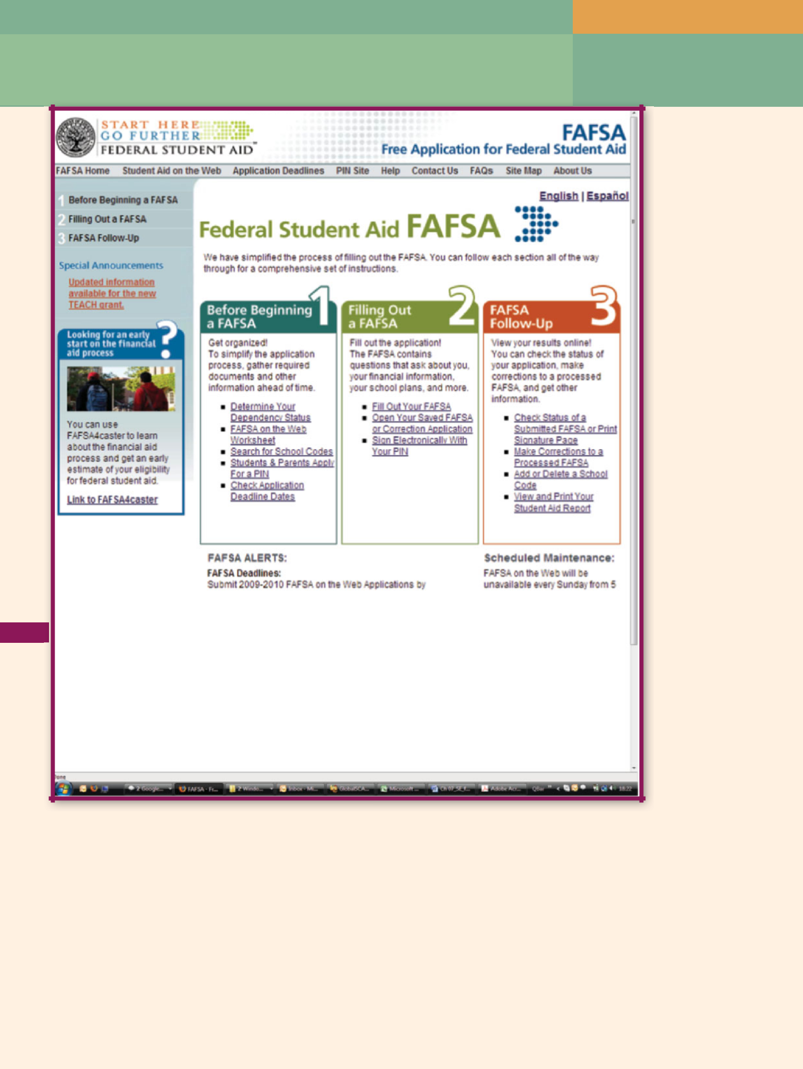

**Sample Web Page**

Writing for the Web **| 165**

****© Ingrid Breyer

Writing@Work

Michael Luongo is an experienced and prolific freelance travel writer based in New York City. For ten years, he has been publishing his work in magazines, in newspapers,

in books, and on the Web. He works with all kinds of publishers, from prestigious ones such as *The New York Times* to specialized and small ethnic publishers.

A versatile writer like Michael knows how important it is to adjust one’s writing style and format for publication on the Web. His rule of thumb is that if you have to print something out to read it, it’s too long to be readable on a screen. In addition, paragraphs in web articles must be shorter than

they usually are in print.

“Think of ways to divide your work into pithy bits that are full of information and catchy,” suggests Michael, “such as top tens and other ‘listy’ ways of writing.” Michael also believes that avoiding the wordiness and punctuation of complete sentences increases readability and highlights the important content.

Web copy also must be interactive and clickable—full of words and images that contain links to other related material. According to Michael, “You want to make your work so clickable that a reader will lose all sense of time with it.”

Michael’s advice to those who want to publish on the Web is to start publishing on the Web. “Create your own website or blog first—since you can control it—and use your name or your specialty as a part of the website or blog name. You should always reserve yourname.com as soon as you can.” For example, Michael’s website is www.michaelluongo.com. “It’s your calling card; your portfolio; and, in my case, part of my dream work as a travel writer.”

**Think Critically**

1. Do you agree with Michael about the length of writing on web pages? Explain.
2. Starting with Michael’s advice in this feature, create a “top ten” list of rules and tips for writing on the Web.

Printed with permission of Michael Luongo

**166 |** Chapter 7

**GETTING STARTED ON WEB PAGES**

WebMD, HowStuffWorks, eBay, Facebook, and Flickr are now household terms. The expression *to google,* which might have been mistaken for kiddy babble ten years ago, shows how quickly the search engine Google has infiltrated not only our homes, but also our lexicon. Over 1.6 billion people worldwide, or nearly 24 percent of the world’s population, use the Internet (Miniwatts). Knowing how to write for these users will give you a critical advantage in the workplace.



Although the terms *the Web* (for **World Wide Web,** a collection of online resources) and the **Internet** are often used interchangeably, they are not synonymous. The Internet, a global system of networks, is the infrastructure on which the World Wide Web as well as other protocols, including e-mail and instant messaging, travel. Think of the Internet as the train track and the Web as one of the trains running on the track.



Warm Up



How do you read a novel? How do you read a website? Do you read both in the same way, or do you read them diﬀ erently? Explain.

**Reading Web Pages**

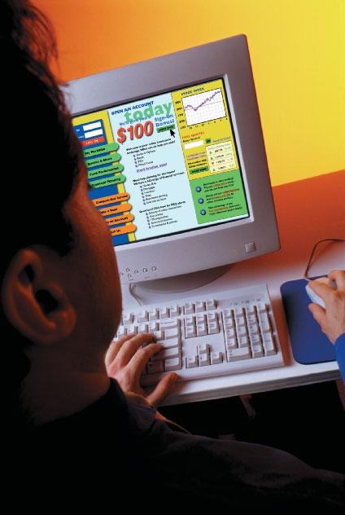

Because of the **interactive** nature of the Internet, with pages that respond to user input, users read online material differently from the way they read printed text. Where people read books and magazines in

a linear fashion from one page to the next, web readers scan pages from the top center, then down from left to right, looking for keywords. Instead of turning pages, readers follow links, jumping from one page to another and one site to another, wherever their interests take them. In this way, readers control the flow of information, and no two readers read a website the same way.

On the FAFSA home page illustrated on page 165, users needing to apply for a PIN click

“Students & Parents Apply for a PIN.” If users already have a PIN, they move to the part of the site that meets their needs at the moment—perhaps “Make Corrections to a Processed FAFSA.” The interaction is more like a conversation as the web page communicates with different users in different ways.

Online readers want speed and convenience. Most people find that just ten seconds is too long to wait for a page to load. If the site glitters with animation but does not give viewers the information they seek, they are not likely to return. Furthermore, readers prefer not to scroll horizontally (to the right) or vertically (down) to find information.

|  |
| --- |
| Brand X Pictures/Getty Images |

Writing for the Web **| 167**

Because of their desire to navigate quickly, readers pick up clues from one page to help them understand the next page. As a web writer, you must be familiar with these clues and adjust your writing to this different way of reading and accessing data.

**Planning Web Pages**

To write text for the Web, you need to think through the basics of planning a document: What is your purpose? Who is your audience? Your challenge is to achieve your purpose and meet the needs of your audience.

***What Is Your Purpose?***

In Chapter 2, you learned to determine the purpose of your writing early in the process and to use your purpose to guide you as you made decisions about your document. Here, too, determining your purpose is important. What do you want to happen as a result of this document? In other words, why does your website or web page exist? What is the reason for your post or discussion?

The purpose of most technical writing is to inform or persuade. In web writing, the purpose might expand to include other goals, such as offering a service, defining an image, soliciting opinions, creating a community, or entertaining people. One site informs customers about cell phone plans, provides a service by recording minutes used, and persuades customers to purchase a smartphone. Your bank’s website projects an image of a responsible, conservative institution. MySpace brings people together, and YouTube entertains as well as informs.



Effective sites make their purpose clear on the **home page** (the first page of a website)—often as a slogan in the heading across the top of the page. Figure 7.1 shows Overton’s home page. The slogan makes it clear that the company sells products for boating and water sports. The dark blue colors remind viewers of water, and the photo of canoes packed with gear support the image of family fun.

Image not available due to copyright restrictions

**168 |** Chapter 7

***Who Are Your Readers?***

Online readers come from all over the world, with English, Chinese, Spanish, and Japanese as the four most popular languages. The audience may include many readers looking for news headlines on MSN.com or a single stock broker looking for Exxon Mobil’s performance in the S&P 500.

Defining the audience for your web-based project will help you get started on your writing. Who is your target audience? Describe this audience as specifically as you can. What are the **demographics**, or defining characteristics, of your audience? In other words, where do they live; how old are they; what is their income; are they male, female, married, or single?



After you have defined your target audience, consider how you can best appeal to your audience. Ask yourself these questions:

What information does my audience need, expect, and want? What will my audience do with this information?

Some members of your audience will have the latest technology; others will not. When planning your site, consider monitor settings, Internet connection speeds, special requirements of hand-held devices, and browsers used by your target audience. Plan for a variety of technology setups and test your page in different browsers (for example, Internet Explorer® and Mozilla Firefox®).

Keep in mind that anyone anywhere in the world can read whatever you put on a web page. You may think that you are selling hand tools to the residents of East Texas, but do not be surprised to receive orders from China or Northern Ireland. Remember, the Internet is always open to anyone with a computer and an Internet connection.

 **STOP AND THINK**

How do visitors read a page on the Web? What issues should a web designer be concerned about when planning a web page?



**ORGANIZING AND DESIGNING WEB PAGES**

Now that you have a clear purpose and a good understanding of your target audience, it is time to organize your material and design your page.

**Organizing Web Pages**

To begin organizing your website, use sticky notes or index cards to list everything you want to include—no more than one item per note or card. Group your items into similar categories, considering the importance of each idea to your users. Place your notes on a white board or bulletin board so you can move them around until you have an outline that works—with topics and subtopics. Common ways to organize information on a website are by category, task, product, date/time, or department.

Warm Up



What is your favorite website? What features make the site stand out? Describe the page—the kind of information, the colors, the graphics. Is the page easy to read? Do you have an easy time fi nding information on this site? Why or why not?

Writing for the Web **| 169**



To fi nd current articles about all aspects of technical communication, including web design and web writing, go to the NET Bookmark for Chapter 7.

Search the articles, looking for advice about blogging, FAQs, wikis, or discussion forums. Print one article, read it, and summarize it. Share your summary in an oral presentation to your classmates.

*www.cengage.com/school/bcomm/techwtg*

Once you have an outline, you can decide how to structure your website. A simple site may move forward in a linear fashion from one page to the next, similar to a flowchart. Other sites organize pages in a hierarchy, similar to an organizational chart. In the hierarchy, information flows progressively from “top” to “bottom” from the home page to a second or third tier in increasing levels of detail. Web design software such as Adobe® Dreamweaver® and Microsoft® Expression® Web 3 provides tools for setting up the structure for a website.

However you organize your pages, you will need to plan for a system of hyperlinks. **Hyperlinks,** also called *links,* are a word, phrase, or graphic used to link, or join, pages within a site or to an external site, allowing viewers to move easily from page to page. Depending on the browser settings, hyperlinks can be a different color, underlined, or graphical. They are activated by scrolling over a word and/or clicking. The goal is to make information accessible in three or four mouse clicks.



External links can enrich a subject with information from another site and reduce content on a page. However, if you plan to use external links, you will want to inform your readers that they are leaving your site and moving to another one. If you use an external link, make sure the link works. It is frustrating for viewers to click on a dead link that does not take them to the page you intended. There is no copyright infringement for providing links to other sites. However, it is illegal to provide a link to a site representing any form of illegal activity.

Not every site makes use of external links, but every site should include a clear system of links to take viewers to pages within the site. Without clear navigation, readers can get lost, wondering how to get back to a page they found interesting. Table 7.1 explains some common ways to provide internal links.



**Focus on**

**Ethics**

Claudia is setting up a website for her floral business, Claudia’s Creations. She is in a hurry to get the site up and running. She wants to show some of the sprays, wedding bouquets, and dish gardens she has created, but she cannot find the pictures she took of them. So she searches the Web and finds designs that she likes on two websites: Floral Fantasia and Flowers by Chenda. Claudia decides to use some of the designs from those sites on her own website until she finds her misplaced pictures or takes new ones.

**Think Critically**

What might happen if Claudia’s customers discover that she used flower designs from other sites?

**170 |** Chapter 7

|  |  |
| --- | --- |
| **Home Page Link** | A hyperlink back to the first page of a site. A home page link |
|  | should be on every page of a site. |
|  |  |
| **Previous Page/Next** | A hyperlink to help readers go back one screen and forward |
| **Page** | to the next screen. |
|  |  |
| **Breadcrumb Trails** | Hyperlinks in a row near the top of the page that show |
|  | visitors the links between the page being viewed and the |
|  | home page. The viewer can click any link in the trail to move |
|  | back quickly in the hierarchy. A good visual clue about |
|  | linking relationships, it should be used in addition to other |
|  | navigation tools. |
|  |  |
| **Site Map** | Hyperlinks that show a hierarchal list (word, phrase, or |
|  | graphic) of information on the site—similar to a table of |
|  | contents. Users can click a link to view a specific page quickly |
|  | without having to go through multiple levels of pages. |
|  |  |
| **Navigation Bar** | A list of links—words, tabs, or pictures—that span the top, |
|  | sides, or bottom of a page and direct users to other pages. |
|  |  |
| **Drop-Down Menu** | A word or phrase, usually at the top of a page, with options |
|  | that open, or “drop down,” when a user clicks the word or |
|  | the arrow. Drop-down menus are useful because the navi- |
|  | gation does not clutter the page, yet the options are still |
|  | available. |
|  |  |
| **Search** | A feature that allows the user to enter keywords and search |
|  | for pages in the site. |
| **Table 7.1** |  |

Figure 7.2 illustrates links—including navigation bars, drop-down menus, and search features—on the home page of Georgia’s official state website.

|  |  |  |  |  |
| --- | --- | --- | --- | --- |
|  | Navigation Bar |  | Site Map |  |
|  |  |  |  |  |
|  |  |  |  |  |

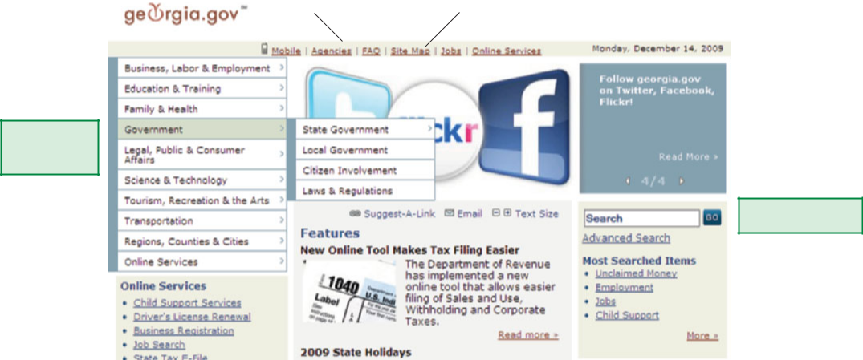

Drop-down Menu

**Figure 7.2** System of Links on a Home Page

Search Features

Writing for the Web **| 171**

**Designing Web Pages**

If users do not have a good experience the first time they access a site, they may not return. Consider **usability**—the ease with which an audience can access and use a site—as the top design principle. In addition to ease of use, web pages should look attractive—uncluttered, symmetrical, and inviting. Use the principles discussed next when designing your website.



***Header***

Create a header, the banner spanning the top of a web page, to set the appropriate image and tone for your site. A site advertising scented candles may use a photo of lit candles, pastel colors, and a simple script font to create a relaxing scene. A site advertising sports cars, on the other hand, might use bright colors, a photo of a red Corvette, and a bold font to evoke excitement.

***Page Layout***

To help readers scan for relevant information, organize information under relevant headings. If your page is too long, divide the information into multiple shorter pages with corresponding links to those pages. If you cannot break up the long pages, place the most important information—the title, purpose, key navigational elements, and search features—near the top so readers see it before scrolling vertically. Do not set up pages so visitors have to scroll horizontally.

***Line Length***

A shorter line length reduces eye movement needed to scan the text. The ideal line length is approximately half the width of the screen, or between 50 and 70 characters (or 10 to 12 words) per line.

***Graphics***

Graphics break up the text, attract the reader’s attention, and offer instant identification with the purpose of the website. Use graphics to provide visual relief, to support your content and image, and to make the site attractive.

A site focusing on the fun and challenge of a rock climbing club would not use a photo of a woman on the side of a wall panicked at the prospect of rappelling back down.

Graphics take time to load, and too many graphics may discourage people from investigating a site. To speed up the download time of graphics, use one of the following formats for compressing files: GIF (Graphics Interchange Format), JPEG (Joint Photographic Experts Group), or PNG (Portable Network Graphics). Use smaller logos as opposed to larger background logos. If more detail is needed, enable users to click the picture to see the full size.

***Multimedia***



Many pages use **animation** (text or graphics that move), audio, and video to make a page more interesting. Although the movement and audio may look and sound good, use them sparingly to support your message. Too much movement may annoy the reader, and if the extra graphics result in the page taking a long time to load, you may lose visitors.

**172 |** Chapter 7

***Tables***

Use tables to organize text and graphics. Tables give the page a uniform, clean, professional appearance. Data can go inside cells, and one table can be nested inside another. Invisible tables form the skeleton that holds the site together.

***Borders***

Use borders around the page to draw boundaries between sections or omit borders for a more seamless look.

***Fonts***

Font sizes and styles affect screen legibility. Sans serif fonts are usually recommended for online text because they look more distinct on a screen. Avoid all capital letters and boldfaced blocks of text because these styles slow down the reader and are the equivalent of YELLING.

As with printed text, you can emphasize important words or phrases with boldface or italics as long as you do not go overboard. Be wary of using underlining. Most viewers associate it with links and expect to be able to click to access another page.

***Colors***

Use colors to help create an inviting site. As you know, colors evoke a variety of emotional responses. Color should reflect the site’s purpose and take into account the target audience’s cultural associations with color. For example, red, often associated with the devil in the United States, is the color of wealth and good luck in China.

Consider, too, the color wheel and use colors that complement one another—for example, yellow and purple, and blue and orange. You want to keep colors to a minimum and use a neutral, white, or very dark background color with contrasting colors for the text. Use accent colors to direct visitors to important content.

***Consistency***

You teach the user how to read your site by repeating certain patterns. Repetition allows readers to anticipate the site’s structure. To achieve consistency, make sure your pages look similar and use the same design features positioned in the same place on every page. A company name and logo that appears in the top left corner of one page, for example, should appear in the top left corner of every page. If the text is dark blue on a light blue background, do not experiment, for example, by changing the scheme on another page to dark blue text on a white background.

***Accessibility***

Whenever possible, follow Web Content Accessibility Guidelines (WCAG) 2.0. These guidelines are part of the **Web Accessibility Initiative (WAI).** Its goal is to make web content available to users with a wide range of disabilities, including visual and hearing impairments, learning disabilities, cognitive and movement limitations, speech disabilities, and combinations of disabilities.



Writing for the Web **| 173**



 Warm Up

How do you read a book? How do you read a web page? Do you read them the same way? Explain.

The MyPyramid home page shown in Figure 7.3 uses three vertical panels. The middle panel uses a white background with black sans serif text of

1 through 11 words per line. The left and right panels use blues and greens, colors that depict calmness and good health. The pyramid logo represents the colors of the various food groups and reminds the reader of the government-sponsored food pyramid. Each page in the site uses the same header across the top, the same top and left navigation bars, the same search feature, and the same three-panel design. The site’s statement about accessibility (not shown in the figure) can be found by clicking the link at the bottom of the web page.

 **STOP AND THINK**

List at least five design principles for the Web. How should color be used? What are some technology considerations?



**WRITING TEXT FOR THE WEB**

In many ways, writing for the Web is similar to writing text for any other technical document. But remember, a web page is viewed on a screen, not on an 8½" 3 11" sheet of paper. The screen influences all pages in important ways. Writing scannable text will help your readers find what they need.

**Strategies for All Pages**

Use the strategies beginning on the next page to keep your pages organized and focused on your audience.

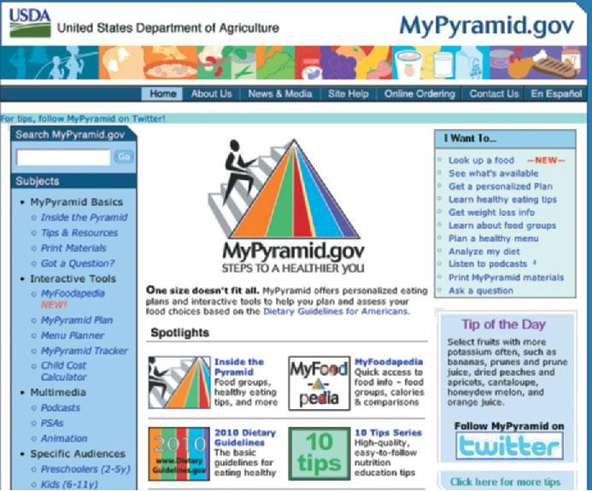

**Figure 7.3** Example of a Well-Designed Page

**174 |** Chapter 7

**WRITER’S FOCUS**

**Organizing information, writing scannable text, designing attractive pages, and providing users several ways to access the information.**

**A person anywhere in the world with a computer and an Internet connection who is scanning pages, clicking links, and expecting to fi nd specifi c information quickly and easily.**

**TYPICAL READER**

***Page Title***

Give each page its own short, descriptive title—something visitors can read quickly in a browser title bar or history list. On the Federal Emergency Management (FEMA) website, for example, each page has a unique title, such as “Plan Ahead,” “Disaster Information,” and “Apply for Assistance.” If you visit these pages, they will be listed in the order in which they were viewed under “History” in the browser window. FEMA and its logo appear in the upper left corner of each page, though, to tell readers they are still on the FEMA website. If readers bookmark a page (or save to Favorites), the page title is stored. Some search tools use page titles in their search results.

***Audience***

Know your target audience and write to that audience. Compare these two sentences from a job hunting website for displaced workers:

**Original:** The JDW site has been set up to help displacedworkers find jobs in their immediate geographical areas whether their expertise is in construction, sales, or engineering.

**Revision:** If you have lost your job, we can help—no matterwhat your area of expertise or where you live.

**COMMUNICATION TECHNOLOGIES**



An RSS (Rich Site Summary or Really Simple Syndication) is a feed or format that regularly updates web content. Just as a single television program is syndicated and sent to many viewers, an RSS is syndicated, too, and sent to many readers. Subscribers receive notices of new content for the sites in their feed. For example, a health feed on Google News provides a summary of current articles about health. Search engines and news sites organize RSS links by content area (for example, Top Stories, Middle East, Business, and Entertainment).

**Think Critically**

What is the benefi t of subscribing to an RSS?

The original example talks about the website. The revised example talks directly to the reader.

Also avoid jargon unless you know your reader will understand it.

***Inverted Pyramid***

State important points before you provide any detailed supporting information. At the website of the Salt Plains National Wildlife Refuge,

the home page begins with what the Salt Plains Wildlife Refuge is and why it exists. Then readers learn about the size of the salt flat, two related habitats, and upcoming events—all in order of importance. The inverted pyramid allows viewers to see the most important content before they scroll down the page.



***Facts, Not Hype***

To keep your web page as informative as possible, state the facts and avoid the hype of an overdone sales appeal. People want information they can use.

**Original:** Are you sitting at home wondering when you’ll meetPrince Charming? Skin Rejuvenation promises to restore skin scarred from acne or sun damage. Order your jar today and see how your life changes.

**Revision:** Skin Rejuvenation moisturizer is easily absorbed, thereby reducingwinter chafing by 15%.

Writing for the Web **| 175**

***Original Phrases***

Avoid the web cliché—the “Click here” or “Check out this site.” A link can be easily made a seamless part of a sentence, as the following examples show:

**Original:** Clickhereto learn how variations in temperature affect the successof gel coat application.

**Revision:** Variations intemperatureaffect the success of gel coat application.

***Standard English***

Use standard English and follow rules of correct punctuation and usage.

Nothing ruins the credibility of a web page more than errors.

**Scannable Text**

Except when the site posts an article or a resume, say as much as you can in as few words as possible. Your goal is to create **scannable** text to enable readers to locate important words and phrases—or keywords—quickly and effortlessly. To reduce words and make your text scannable, follow the suggestions discussed next.



***Short Paragraphs***

Use short paragraphs that stand out and can be quickly scanned and absorbed, usually six to eight lines. A single, well-worded sentence can stand alone as a paragraph. See the visual relief in the thumbnail sketch in Figure 7.4 where one longer paragraph is separated into three.

***Short Sentences***

While sentences can vary in length, aim for an average of 20 to 25 words per sentence. The revised sentence below is much clearer and easier to read when it is written as two shorter sentences.

**Original:** Set in the rustic Craghill Mountains near the small town of Wilcox,Tennessee, Spring Village, conveniently located close to a transportation center, medical center, and cultural alcove, is a caring community for seniors.

**Revision:** Set in the rustic Craghill Mountains near the small town of Wilcox,Tennessee, Spring Village is a caring community for seniors. It is conveniently located close to a transportation center, medical center, and cultural alcove.

***Headings***

Use short but informative headings to help readers identify topics and decide at a glance what they want to read. Headings also provide transitions to the next topic, alerting the reader to shift from one idea to another. For example, to help

|  |  |  |
| --- | --- | --- |
|  |  |  |
| _______________________ |  | _______________________ |
| _______________________ |  | _______________________ |
| _______________________ |  |  |
| _______________________ |  | _______________________ |
| _______________________ |  | _______________________ |
| _______________________ |  | _______________________ |
| _______________________ |  | _______________________ |
| _______________________ |  | _______________________ |
| _______________________ |  | _______________________ |
| _______________________ |  |  |
| _______________________ |  | _______________________ |
| _______________________ |  | _______________________ |
| _______________________ |  | _______________________ |
|  |  |  |
|  |  |  |
|  |  |  |



**Figure 7.4** Long Versus Short Paragraphs

**176 |** Chapter 7

readers locate information in its web page, the Community Orchestra provides three headings: Upcoming Performances, How to Join, and Director’s Notes.

***Paragraphs to Lists***

Use bulleted lists to break up paragraphs, reduce the amount of text, and emphasize important content. The following list of e-mail “don’ts” is easier to scan than the paragraph with the same information.

**Original:** Respect your e-mail recipient’s privacy and time by not sendingchain e-mails. They are hoaxes and waste your reader’s time. It is presumptuous to send attachments or other people’s e-mail addresses unless you have permission to do so. Sending multiple postings to people who are not interested wastes time and takes up storage space. Finally, do not “Reply to All” unless it is necessary.

**Revision:** DON’T

Send chain e-mails.

Send attachments or other people’s e-mail addresses unless you have permission to do so.

Send multiple postings to people who are not interested. “Reply to All” unless it is necessary.

***Keywords***

To help search engines and your audience find your website, in approximately the first 50 words of your text, use **keywords,** important words that indicate subject areas. To fi nd useful information, readers scan text looking for keywords and phrases. Keywords for a mythology website include *Joseph Campbell, The* *Hero with a Thousand Faces, myths, hero, Departure, Initiation, Return, Call to Adventure,* and *Healing and Reconciliation.* Which of the following versionsdoes a better job of including more keywords in the first 50 words?



**Original:** Joseph Campbell compared myths of the hero from all over theworld. He found similarities in the myths and identified 12 stages of the hero’s journey. Below are Campbell’s stages with a short explanation. The explanations and stages are typical of the journey but may not be found in all [50 words] myths. The stories and their plots are similar, but the characters and circumstances differ. Campbell’s work is compelling. For more information, see his landmark book, [75 words] *The Hero with a Thousand Faces.*

**Revision:** In his book*The Hero with a Thousand Faces,*Joseph Campbellidentifies 12 stages in myths of the hero’s journey. The journey takes place in three parts: hero’s Departure, Initiation into the journey, and Return

to improve society. From the Call to Adventure through Healing and Reconciliation, the hero receives [50 words] Supernatural Aid, passes into the Darkness of the Realm of Night. . . .

In the original version, Campbell’s book is not even mentioned until after 75 words into the passage. The second passage is more concise, relaying significant information in every sentence.

All of these suggestions have one goal—to make information useful and accessible.

Complete the *Paragraphs to* *Lists* worksheet available atwww.cengage.com/school/ bcomm/techwtg. Click the link for Chapter 7; then click Data Files.

Writing for the Web **| 177**



 Warm Up

To show that you have already practiced strategies for special kinds of web writing, describe your experiences with one of these situations: (1) choosing a theme for a prom, a dance, a reunion, or a holiday event; (2) keeping a journal;

1. answering the same questions over and over;
2. collaborating on a project; or (5) writing answers to discussion questions.

 **STOP AND THINK**

Explain three overall writing strategies for web pages. Explain five ways to write scannable text.



**SPECIAL WEB PAGES**

The Web offers a new medium for established ways of communicating. The type of writing is not altogether new, but when the audience and medium change, good writers adapt. The result? New avenues of writing for existing genres. Five of these adaptations are outlined next: home page, blog, FAQ, wiki, and discussion forum.

**Home Page**

Think of your website as a theme park. Your park may have many areas— rides, a petting zoo, edutainment, restaurants, and more—or a single nature trail. The home page of your website is like the entrance to the park. Because you want many visitors, you design an inviting entrance, one that refl ects the theme and offers basic information to help people navigate the site. Like a home page, there may be several ways to get from one area to the next inside the park. Use the following tips when writing text for a home page:

**Get your reader’s attention and announce your purpose.** Use a catchyphrase and meaningful slogan. For example, a website devoted to transferring photos and videos to DVDs might replace its title and slogan with something more appealing, as follows:

**Original:** title “Photo Transfer”; slogan “We turn photos into DVDs.”

**Revision:** title “Keepsake Photos”; slogan “Keeping your memoriessafe.”

**Write a short introduction and conclusion.** The introductionexplains the purpose of your website. The conclusion brings the page to a close. Consider the introduction and conclusion on the Keepsake Photos site.

**Introduction:** “We transfer photos, 8mm film, and video into qualityDVDs.”

**Conclusion:** “We’d like to help you preserve your special memories.”(after explaining about the company, its guarantee, and its contact information)

**Consider links to short online articles.** You may want to includeFrequently Asked Questions (FAQs) and Tips on your website. On the Keepsake Photos site, the FAQ might answer questions about how to mail the photos or videos and Tips might tell readers how to safeguard their photos and videos.

**178 |** Chapter 7

**Include essential information.** A home page should include the followinginformation:

* 1. Contact information telling readers how to contact the owner of the site—e-mail, phone number, and/or street address
  2. A logo or graphic that helps “brand” the site, creating product and company recognition at a glance
  3. An About section describing the organization and providing some of its history
  4. A system of navigation to help readers find their way around the site
  5. A date (usually at the bottom) showing the last time the site was updated
  6. Any disclaimers or privacy/security statements—what kind of information may be collected by the site and what monitoring systems may be in use to track information

Figure 7.5 shows the home page of Hold Fast Custom Builders, a small construction business. The page has the characteristics of an effective home page: a logo, a slogan, and essential information.

**Blogs**



Similar to a journal or diary, a **blog** (short for *weblog*) is a website with periodic commentary or news posted in reverse chronological order. A blogger is usually an individual with special knowledge or passion about a topic. Because viewers can respond, a blog is not only a source of information, but also an online community. In addition, a blog may include links and graphics.

There are as many blogs as there are content areas. A doctor posts her administrative struggles, a news reporter posts commentaries about the day’s events, and a businessperson posts progress on the development of a new product. The writing style used on a blog is informal. As with any web material, blogs should be read with a critical eye. Some blog “conversations” provide current, credible, and insightful news. Others merely vent and ramble.



Complete the *Critiquing* *a Web Page* worksheetavailable at www.cengage. com/school/bcomm/techwtg. Click the link for Chapter 7; then click Data Files.

**Figure 7.5** Example of a Home Page

Writing for the Web **| 179**

Many sites host blogs, including Livejournal.com, blogger.com, and Techcrunch.

com, along with major search engines such as MSN and Yahoo!.

To post a credible blog,

Write blogs on topics you know about or about which you are passionate.

Post regularly so that you build up a following, but do not overwhelm readers with too many posts.

Create a short name that is easy to remember. Communicate with people on other blogs.

Post meaningful, accurate blogs.

Make your blog site attractive and interesting. Let your personality come through.

Use **RSS** (Really Simple Syndication), standardized web feed formats to send the content of your blog directly to your readers. By using RSS, your readers will not have to visit your website to get updates.



**FAQ**



**FAQ,** pronounced*fak*or*f-a-q,*is an acronym for*Frequently Asked Question*(and *Frequently Answered Question)*. A FAQ is what its name implies— questions asked often enough to warrant publishing so that other people can benefit from the answers. The assumption is that if a sufficient number of people have asked these questions, the questions must be common enough that others will have the questions too. FAQs are found all over the Internet. There is even an archive of FAQs at www.faqs.org/faqs.



**Communication**

**Dilemma**

Julian Mills, a local politician and long-standing member of the Sandhills community, is on the Board of Trustees for Hope Center Hospital. He maintains a blog on his political initiatives, including the construction of the hospital’s new cardiac wing. So far, he has expressed concern over the cost of the wing, the many delays, and some decisions about equipment. Overall, though, he supports the construction and is proud to have played a role

in such a state-of-the art facility. A local reporter, Sabrina Klein, also keeps a blog about area events. Her husband happens to be an architect for the company contracted to build the cardiac wing. In her blog, Sabrina criticizes Julian, saying, “Mr. Mills . . . nitpicks about decisions and micromanages the day-to-day operations of the board. He knows nothing about construction and is clearly pushing a political agenda. He should step down from the board.” Julian, understandably angered by the remarks, wonders what, if anything, he should do about the remarks.

**Think Critically**

What factors should Mr. Mills consider before he decides whether to respond?

**180 |** Chapter 7

You may want to use a FAQ for a website. Or you can post a FAQ on Yahoo! Answers, a site that hosts a variety of FAQs maintained periodically by authorities in various fields. If you routinely respond to customer service calls, written FAQs can help you answer questions about your product.

To compile a FAQ,

Determine the most frequently asked questions. What do your readers ask? What do your customers ask? What do they want to know?

Ask the question the way your readers will ask the question. Use the readers’ terms—the readers’ vocabulary.

Set up a consistent format to set questions apart from the answers— perhaps boldfacing questions and providing adequate white space between questions and answers.

Keep the answers relatively short. One or two sentences is preferable, but no more than a couple of paragraphs. Embed links to other pages on your site or to external sites for more detailed information.

Update your FAQ periodically to keep the information current.

Organize questions in order of importance or in chronological order for your reader.

Proofread for clarity and correctness to keep your FAQ professional.

On a website, place the FAQ where your readers can easily find it—in links on the side, at the bottom, near Help items, or close to information about which readers may be curious.



|  |
| --- |
| ©PricelessPhotos, 2009/Used under license from Shutterstock.com |

**Wikis**



A **wiki** uses special software that allows a number of users to collaboratively author web pages, usually according to a set of guidelines.Wikipedia and BookShelved, provide open access to anyone. Other wikis are closed, and only Some wikis, such as Wikipedia people granted access can contribute. Medpedia, for example, is a medical wiki that allows only professionals to edit content. A wiki can foster creative collaboration for a process, such as programming code. Writers use wikis, too, to post articles and allow other writers to edit them.

If you are interested in participating in a wiki,

Read several articles so you know how the text is written and edited. Become familiar with the process for editing articles in the wiki.

Keep your tone polite and civil—even when you disagree. Keep the tone neutral and the information factual.

Writing for the Web **| 181**

Work toward consensus as you edit.

Include references for information from other sources.

**Discussion Forums**



Operating like an electronic bulletin board, a **discussion forum** is a place where users can discuss items of interest or get specific questions answered. On the Apple website, for example, a discussion forum attempts to answer questions about Apple products and applications. A person who is having difficulty downloading iTunes might post a question and receive responses through this forum. Online discussion forums exist for nearly every topic imaginable—the stock market, art, architecture, business, family, science, and more. The major news networks post online discussion forums. In addition, forums can be found on Google Groups and are an integral part of online classes. Look for a discussion forum that meets your needs.

To interact with a discussion forum,

Read other posts to see how people generally respond.

Provide as much information as possible when posting a concern. Provide accurate information when responding to a concern.

Think critically about others’ responses. Not every response is credible. Be concise.

Whatever kind of text you write for the Web, keep in mind two guiding principles—the needs of your readers and the limited space on the screen. To keep readers engaged, design attractive sites that support your message and deliver valuable information. To help readers find the information they need, write text that can be scanned quickly. The tips below are sound advice for any technical document, but they are imperative for the web writer. Strive for a successful technical style by using:

Concise wording. Short paragraphs.

An inverted pyramid (main idea first). Meaningful headings and titles.

Bulleted lists.

Standard English.

 **STOP AND THINK**

Name five types of writing assignments adapted especially for the Web. Choose two and describe them in detail.



**182 |** Chapter 7

**Chapter 7**

**Review**

**SUMMARY**

1. When creating a web page, know how users read and interact with material, determine your purpose, define your audience, and find out the technology limitations of your audience.
2. When organizing and designing a web page, choose a system of internal links, create web pages that are easy to use and attractive, and keep the design consistent and accessible.
3. When writing web pages, create unique page titles, write to your audience, organize using an inverted pyramid, compile factual content, use original language, and construct scannable text.
4. When writing home pages, blogs, wikis, FAQs, or discussion forums, follow established protocols.

**Checklist**

Have I defined my audience?

Have I written web pages that adjust to the unusual way readers read them? Have I considered the technology limitations of my audience?

Have I determined my purpose and included it in a slogan on the website? Do my text and graphics support my purpose?

Have I organized my website using a workable system of internal links?

Have I designed attractive web pages with easy-to-locate information for visitors to my site?

Do my pages load quickly?

Have I written text that uses unique page titles, is written directly to my audience, organizes material in an inverted pyramid, is factual, avoids clichés, and uses standard English?

Have I written scannable text with short paragraphs, informative headings, lists, and keywords in the first 50 words?

Have I followed standard protocol for my home page, blog, FAQ, wiki, and discussion forum?

Writing for the Web **| 183**

**Build Your Foundation**

1. Rewrite these sentences, breaking them into shorter sentences and deleting extra words.
   1. We offer Spanish tutorials and practice for the beginner as well as the intermediate Spanish learner on a variety of topics so a traveler can feel comfortable traveling in a Spanish-speaking country.
   2. Take time to visit our website at www.homedezigns.com to see the latest collection of living room, bedroom, and kitchen furniture along with accessories such as lamps, vases, and art—from contemporary to traditional.
   3. Because water conservation is important, there are many ways people can help conserve water, including taking showers instead of taking baths and running the washer and running the dishwasher only when they are full.
   4. Spruce up your resume, network with the right people, and organize your job search to increase your chances of finding a job so it does not take you the normal four to six months to find one.
2. Brainstorm possible slogans, color schemes, graphics, and links for one of these sites. Conduct research if you need to familiarize yourself with the type of business. Share your written plan with the class.
   1. Nehu’s Chiropractic Care, new to the area, wants a site that describes services and teaches the public about the value of chiropractic care.
   2. Krischler’s Insurance Services offers personal and commercial policies, including car, home, long-term care, life, and commercial, for a small community.
   3. Beach Getaway is a real estate agency specializing in ocean view rentals for family vacations.
   4. Eastern Music Company sells musical instruments to school bands.
   5. Helping Handz is a charity organization in North Dakota that collects winter coats for children in grades K–12.
3. Improve the following block of text by breaking it up into three paragraphs and shortening some of the sentences.

Global warming—the explanation goes something like this: Energy from the sun heats the earth, and then some of that energy is sent back into space in the form of infrared radiation. A portion of that outgoing radiation, though, is blocked from escaping into space by the earth’s relatively thin atmosphere—a good thing because the infrared radiation that remains stabilizes the earth’s temperature. A problem occurs when the atmosphere, subjected to increasing amounts of carbon dioxide and other greenhouse gases, thickens to trap more of the sun’s infrared energy, preventing its escape from Earth. More trapped energy raises global temperatures—thus the term *global warming.* Global warming can drastically alter the climate. The predictions are frightening: melting polar ice caps, rising ocean levels, category 5 hurricanes. Are these dire predictions true? Are we really in a period of global warming? The body of scientific evidence does suggest that global warming is a reality.

1. Go to About Wikipedia (http://en.wikipedia.org/wiki/Wikipedia:About) to learn more about this open source wiki. Make a list of what you learn.

**184 |** Chapter 7

**Your Turn**

1. Create a sketch of a home page on a topic of interest. Draw your page, cut pictures out of magazines, download clip art, write or key names of links, and come up with the slogan. If you are familiar with HTML code or a web authoring system such as Dreamweaver®, design the page yourself.
2. Find two websites—one that follows most of the guidelines presented in the chapter and one that does not. Write a one-page analysis explaining why one website is more effective than the other. Use bulleted lists to set up your comparison and introduce each list with a couple of sentences.
3. Write a FAQ on a topic of your choice. Choose from your school, your major, your job, or any topic with which you are familiar.
4. Use the topic below to practice the collaboration required by a wiki. Working with four of your classmates, enter the passage in a word processor. Send the file to each member of your group—perhaps over several days. Each person should find one or two errors and add one or two pieces of information to make the passage more interesting. Remember to provide references if you quote or introduce new information.

Henry David Thoreau was born July 17, 1812, and died May 6 1862. He was an American poet, essayist, naturalist, and song writer. He was a strict abolitionist. His transcentral views can be seen in his lectures and most notably in his book *Weldene*. Perhaps his most influential work is “Civil Disobedience” which was inspired by his time spent in Portugal. “Civil Disobedience” influenced such political leaders as George Washington, Martin Luther King, and Mahatma Gradson.

1. For this mock wiki, work in groups of five. In your group, pass around the terms one at a time—perhaps over several days. Each person defines two terms and adds one or two pieces of information or deletes information that should be more accurate.

blog

wiki

breadcrumb trails

Wikipedia

RSS

hyperlink

discussion forum

keywords

1. Write a discussion response to these questions: How has the Internet helped you in your education? What have you learned from this chapter?
2. Go to Google Groups at http://groups.google.com. Join a discussion group that you find interesting. Respond using the strategies presented in the chapter. Print your responses and submit them to your instructor.

**Community Connection**

1. Write a FAQ about a topic related to your school or community—such as how to establish residency, how to join a community group, or how to select an area restaurant. Ask if your FAQ can be placed on the organization’s website or place your FAQ in a central location such as a bulletin board.
2. Interview a blogger or a web designer. Ask about the challenges of blogging or designing a website. Write a summary of the interview.
3. Find someone in your community who has little Internet experience. Show that person how to conduct an online search. If necessary, meet at a public place that has computers and an Internet connection.

Writing for the Web **| 185**